Cocktails at The Mermaid.

- Bellini -Peach Schnapps, Peach puree & Prosecco

- Bloody Mary -Vodka, Tomato Juice & spices to taste

- Brandy Alexander -Cognac & Crème De Cacao Cream

- Cosmopolitan -Vodka, Triple Sec & Cranberry Juice

- Long Island Tea -Vodka, Gin, Tequila, Triple Sec, Lime & Cola

- Manhattan -Rye Whiskey, Martini Rosso & Bitters

- Margarita -Tequila, Triple Sec & Lime

- Martini -Vodka or Gin, Dry or Dirty

- Mojito -Rum, Mint, Sugar & Limes

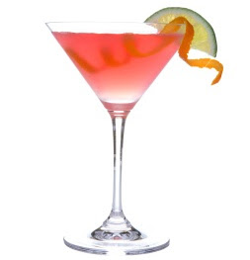
- Sex on the Beach -Vodka, Peach Schnapps, Cranberry & Orange Juice

All Cocktails £6.00

All cocktails shaken or stirred by Ian, our Award Winning Mixologist.
Nothing you fancy?
He will create something to warm your cockles on a winters evening!!!

